Chapter 31 Programming

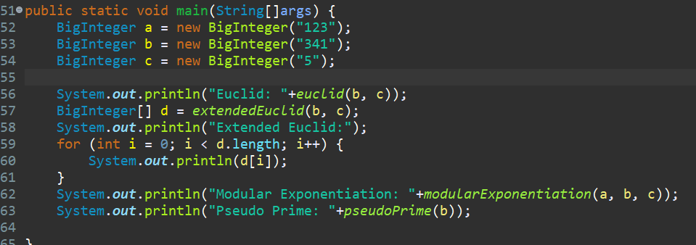

For these, I simply converted the pseudocode in the book. To be entirely honest, I don’t quite understand how any of the algorithms work.

